Day 6 : 18 Sep 2024

Limitation of Jdbc or JdbcTemplate

1. Using JDBC we can’t store the record in database as object as well as we can’t retrieve object from database. We need to convert object to query or query to object in DAO layer.
2. JDBC throw check exception and Exception hierarchy is database dependent. Exception hierarchy is database dependent.
3. JDBC use SQL and SQL is database dependent.
4. JDBC doesn’t support relationship ie is a (inheritance) has a (inside one class creating another class objects).

ORM : Object Relation Mapping

ORM is a tool or concept like OOPS. In Programming language object and database table also known as relation.

OOPs language database

@Entity

class Product { Product table

@Id

pid,pname,price variables PID,PName,Price are column

}

Mapping

Product (class) ---- Product table

Pid --- PID PK

PName –PNAME

Price – PRICE

Old version ORM tool we are/were doing this mapping using xml.

Now way day we can do this mapping using annotation.

@Entity : this annotation we need to write on Java bean class.

@Id: this annotation we need to use on property that property which map to colum with PK.

@Table this annotation we need to use on class level. If table name or java bean class name different.

@Column : this annotation we can use on property level. If variable name in java bean class and column name in table mismatch.

In Java We use 2 orm tool

1. JPA (Java Persistence API) : JPA is a technologies part of java. It is belong to EJB. JPA is a specification as well as implementation
2. Hibernate : Hibernate is a framework. Provided by jboss. Hibernate is one of the implementation of JPA.

Without spring framework if we want to use ORM ie JPA or Hibernate

We need to provide database configuration details.

Hibernate JPA

hibernate.cfg.xml persistence.xml file

this file hold database details like driverName,url,username and password

SessionFactory EntityManagerFactory

It is like a Connection in jdbc. These API load respective xml file and get the connection

Session object EntityManager

These two api provide set of method which help to store the java bean class object ie entity class.

Like a PrepearedStatement which provide set of method to store/retrieve the data

save persist

delete remove

update merge

find get

Core Java project with we can use Hibernate or JPA.

Servlet or JSP with we can use Hibernate or JPA

Spring framework with boot we can use Hibernate or JPA.

Using Spring boot we can use JPA not Hibernate API directly.

Spring framework doesn’t provide any ORM tool. They allow use to integrate with existing ORM like using Spring ORM modules.

Spring boot with JPA with MySQL dbc We Do Crud Operation.

Starter 🡪 web starter controller

Starter 🡪thymeleaf view

Starter 🡪 JPA

Dependency 🡪 MySQL connector

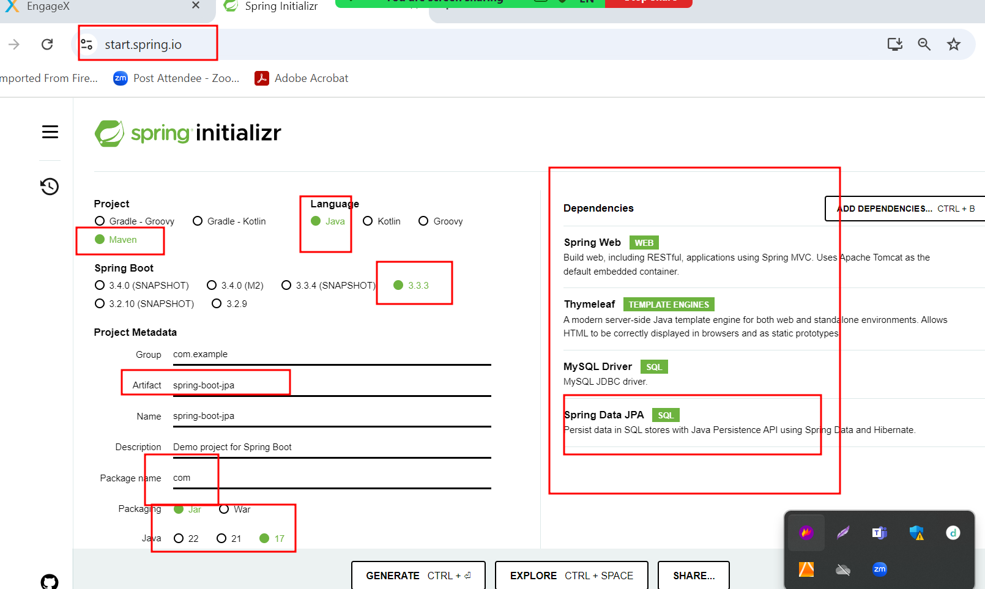

By default JDBC all DML query auto commit.

But if we want to do transaction using jdbc then in connection object we need to write

con.setAutocommit(false);

then after DML operation

con.commit() or con.rollback();

ORM by default doesn’t auto commit. We need to use Transaction in hibernate as well as jpa.

SQL Vs JPQL

SQL

Select \* from product; \* means all column and product table name not a case sensitive.

Select \* from product where price > 45000; here price is column name

JPQL

Select p from Product p; p is object which contains all variables and Product is entity class name. case sensitive.

Select p from Product p where p.price > 45000 here p is object and price is variable name.